# **Software Engineering Assignment**

**MODULE: 3 SE – Fundamentals of Programming**

**Display This Information using printf**

1. Your Name 2. Your Birth date 3. Your Age 4. Your Address

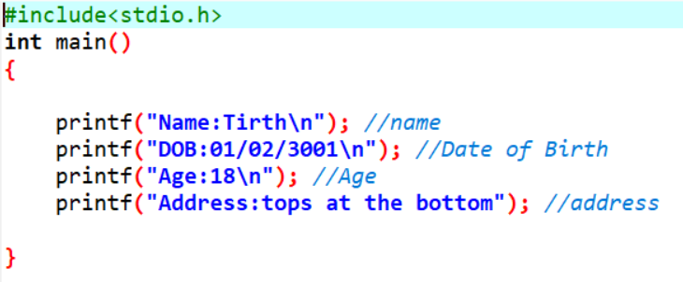

**OUTPUT:**

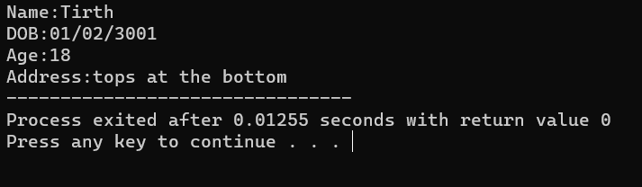

**Write a program to make Simple calculator (to make addition, subtraction, multiplication, division and modulo)**

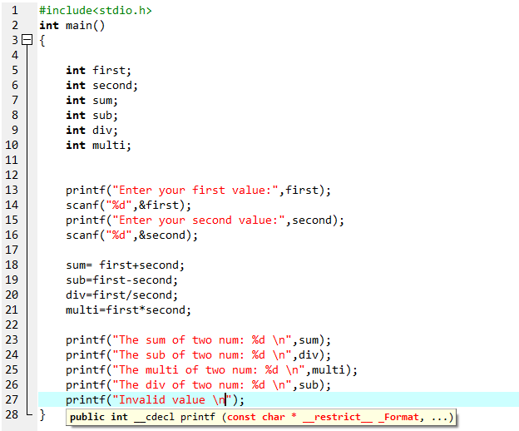

**WAP to find area of circle, rectangle and triangle**

**Area of circle:**

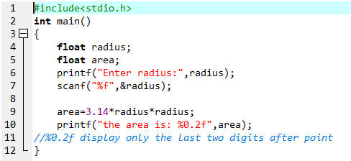

**Output:**



**Area of triangle:**

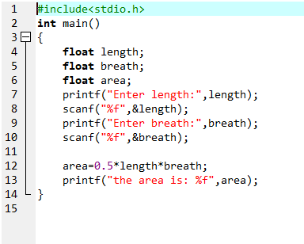

**Output:  
**

**Area of rectangle:**

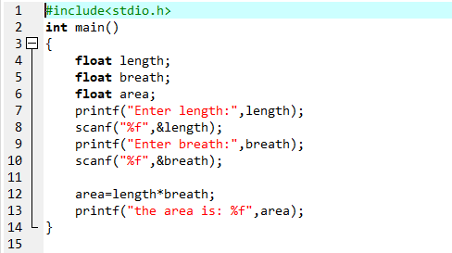

**Output:  
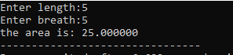**

**WAP to find simple interest:**

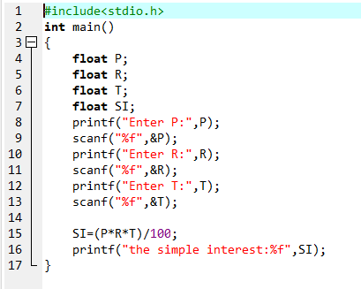

**Output:  
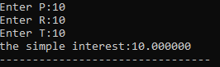**

**WAP to check if the given year is a leap year or not.**

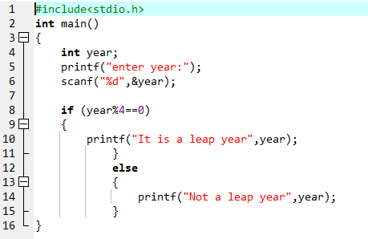

**Output:  
**

**WAP to convert years into days and days into years**

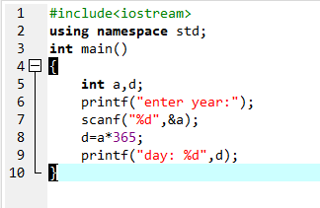

**Output:  
**

**WAP to swap two numbers without using third variable**

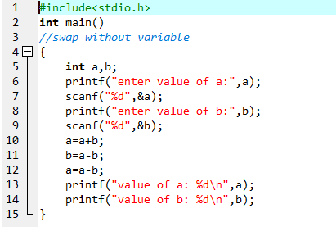

**Output:  
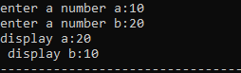**

**WAP to find number is even or odd using ternary operator**

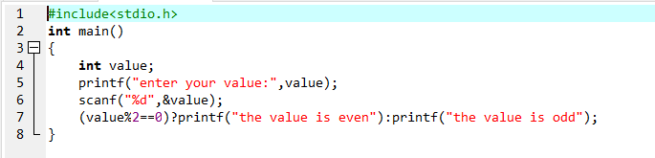

**Output:  
**

**WAP to show**

1. Monday to Sunday using switch case

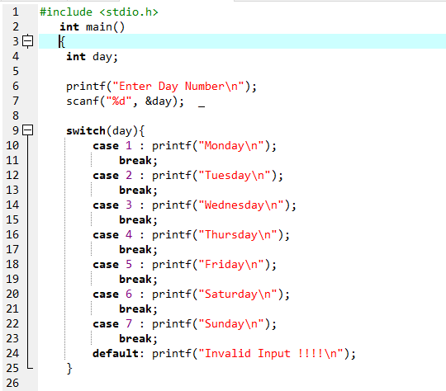

**Output:**

1. Vowel or Consonant using switch case

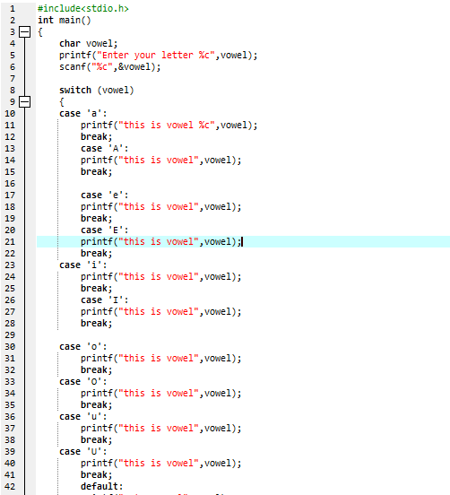

**Output:  
**

**WAP to print 972 to 897 using for loop**

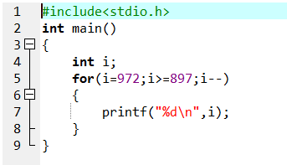

**Output:  
**

**WAP to take 10 no. Input from user and identify whether its odd or even**

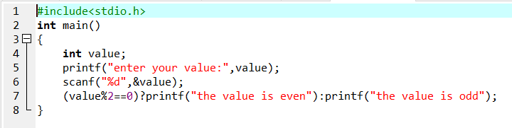

**Output:  
**

**Sum of Odd and even numbers**

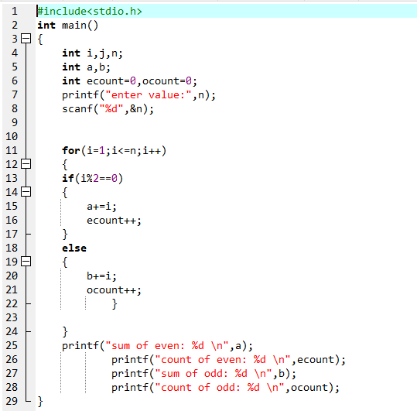

**Output:  
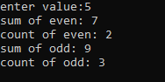**

**WAP to print factorial of given number**

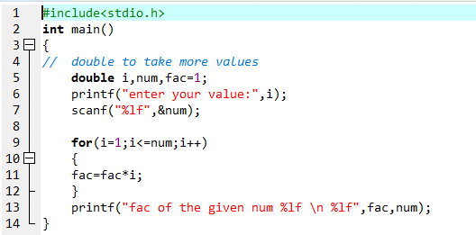

**Output:  
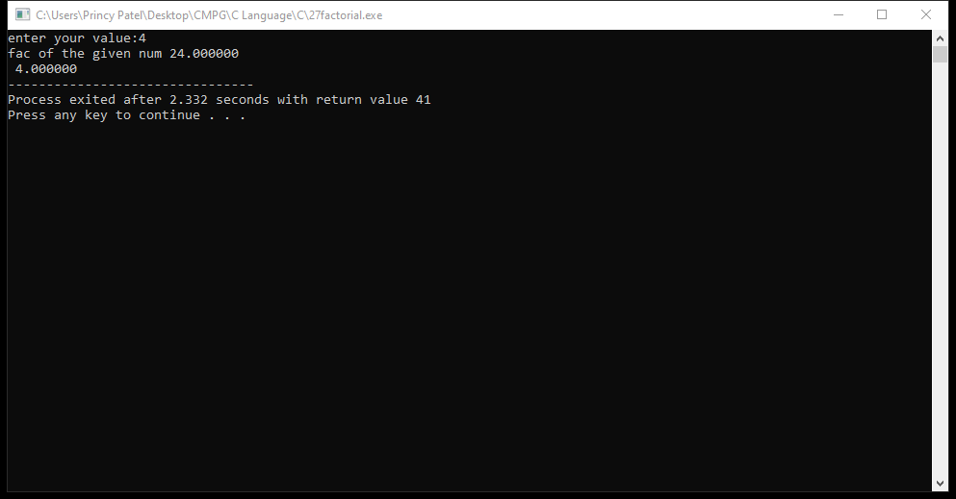**

**WAP to print Fibonacci series up to given numbers**

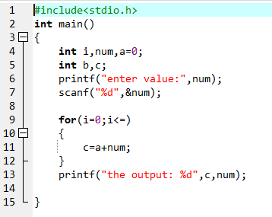

**Output:**

**WAP to print number in reverse order e.g.: number = 64728 ---> reverse = 82746**

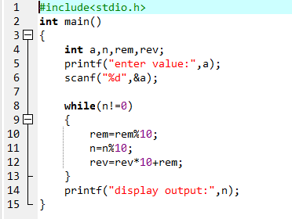

**Output:**

**Patterns:**

**Full pyramid:**

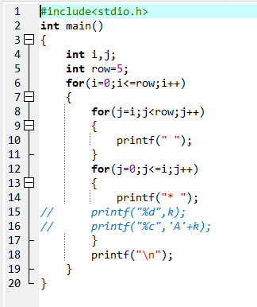

**Output:  
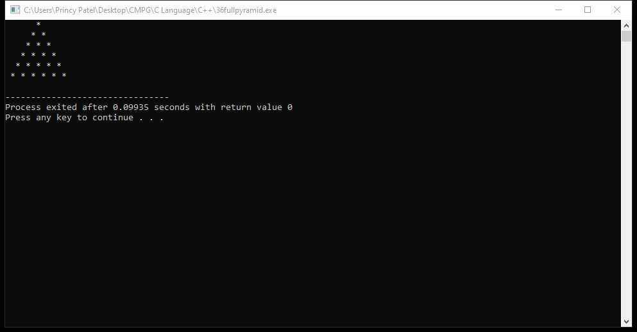**

**Alphabets:**

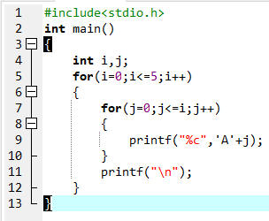

**Output:**

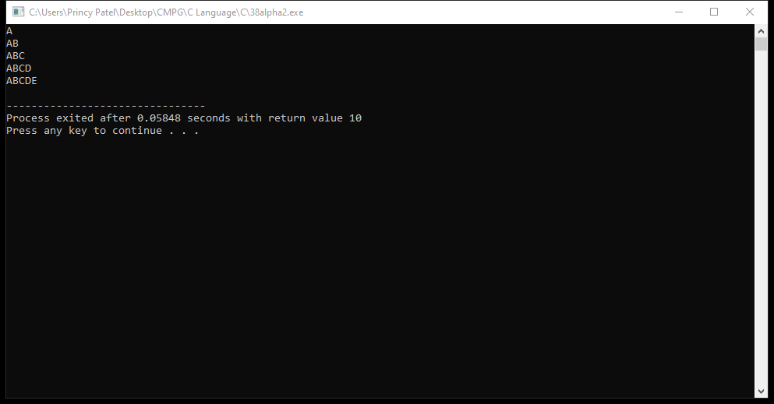

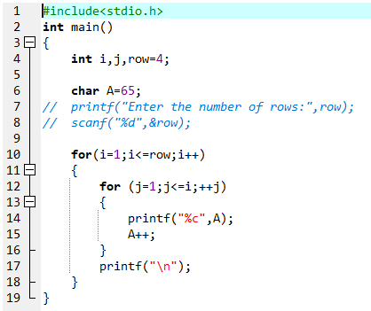

**Output:**

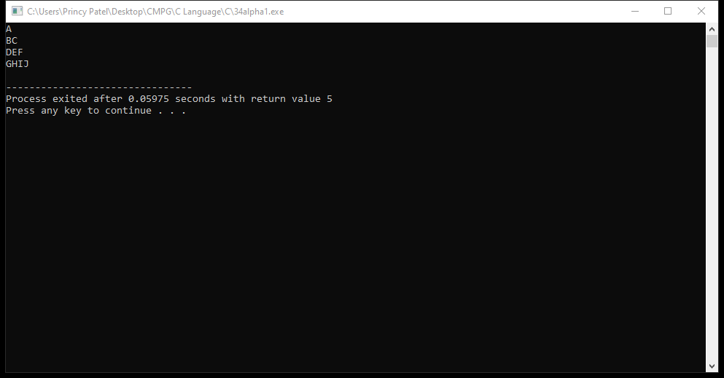

**Number:**

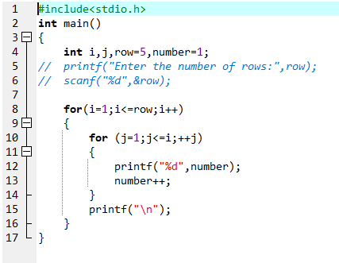

**Output:**

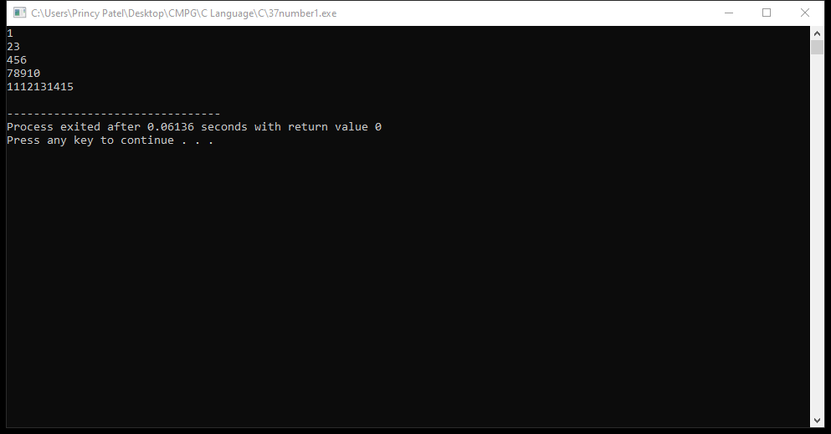

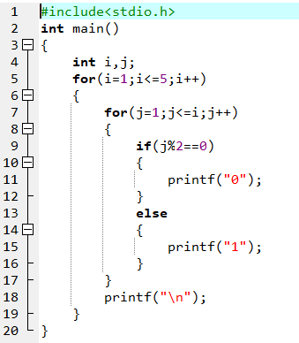

**Output:  
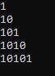**

**WAP to print table up to given number**

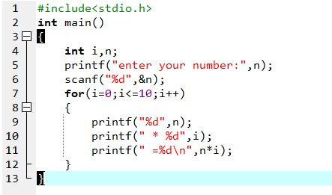

**Output:**

